--TEST 7

1)Create a SSIS package for Execute package task   
2)create a SSIS package for SSIS logging in notepad file .   
3)create a SSIS package for error handling   
4)create a SSIS package that generate a CSV file that contain all orders that placed by customer that name start with a

1. Create a SSIS package for Execute package task

Ans:

Package 1: Execute SQL Task

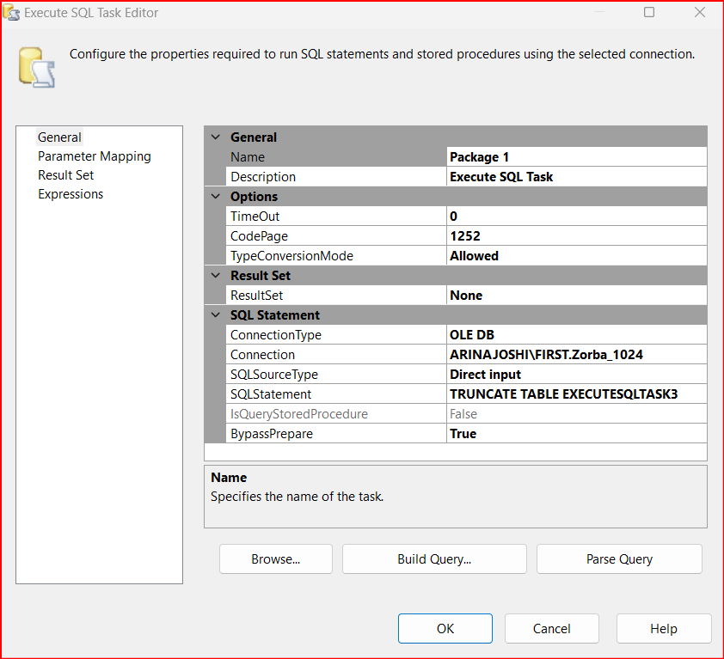

Package 2: Data Flow Task

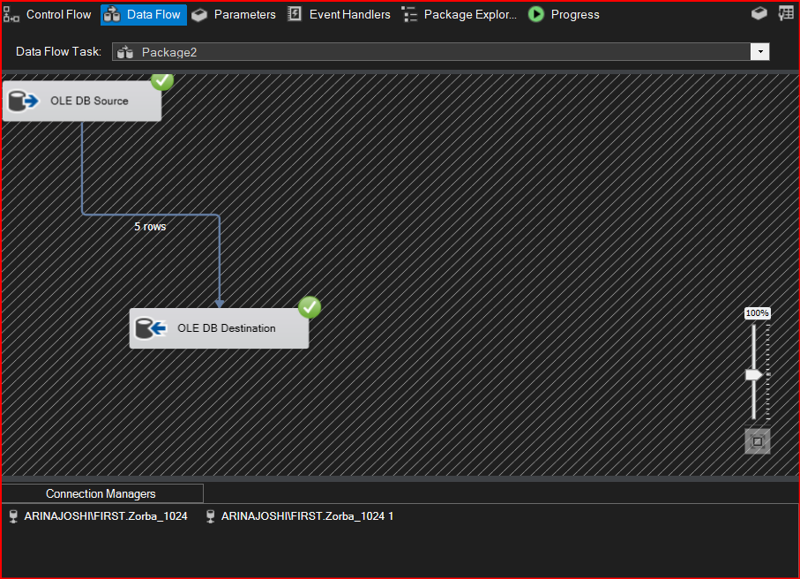

Execute Package Task Configuration:

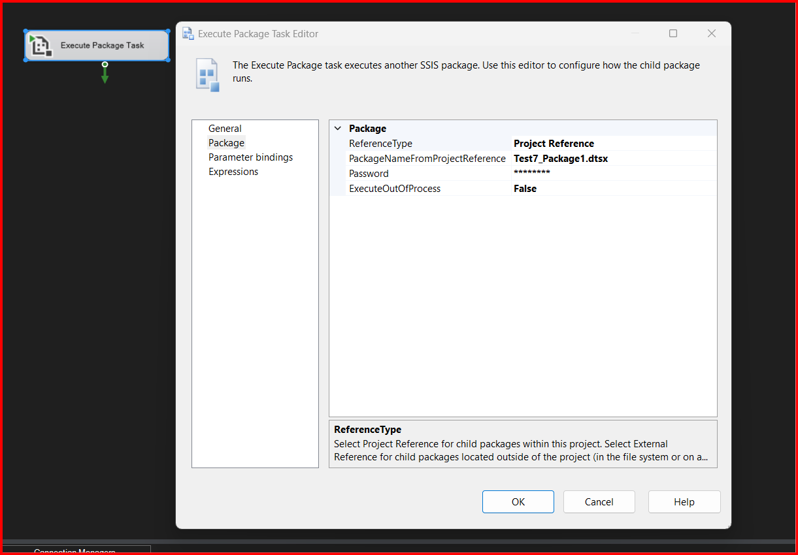

Execution:

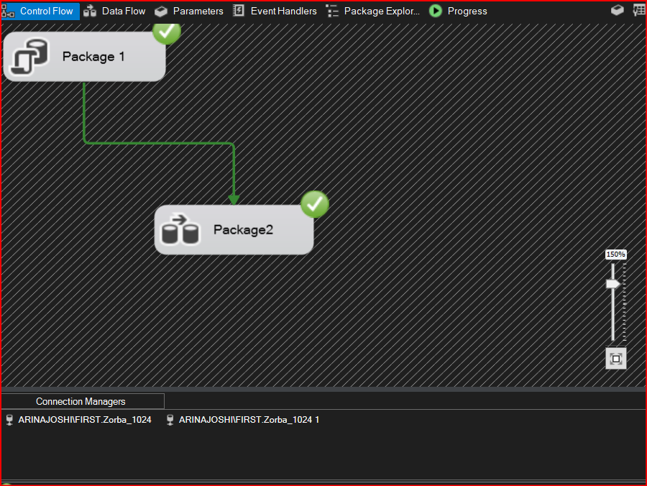

2)create a SSIS package for SSIS logging in notepad file

Ans: Didn’t get checkbox for Package container( Problem not solved yet)

3)create a SSIS package for error handling

Ans:

Flt file source:

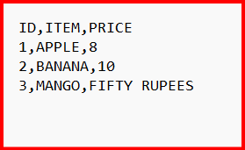

Error Handling Execution:

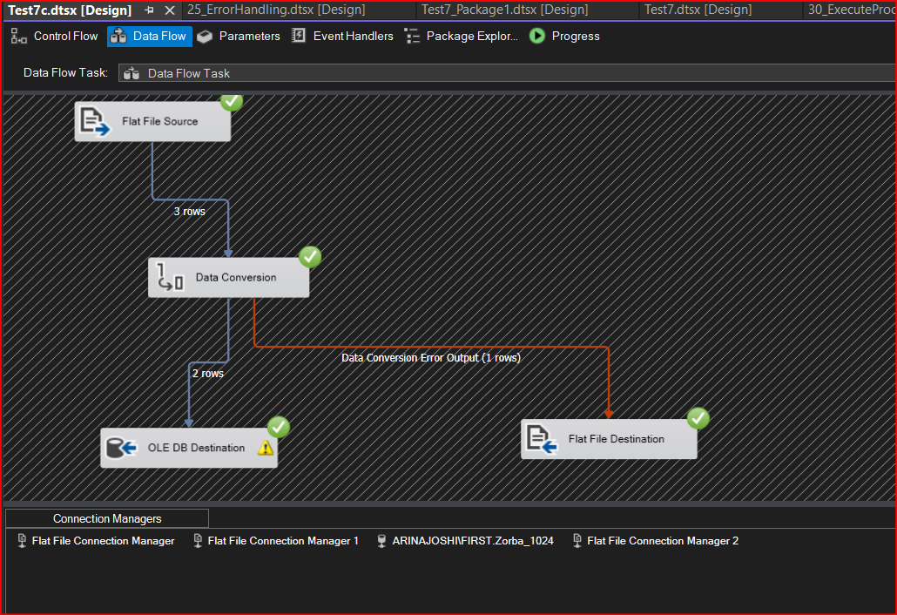

Output in SSMS:

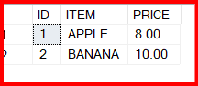

Error output in Flat file:

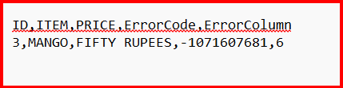

1. create a SSIS package that generate a CSV file that contain all orders that placed by customer that name start with a

Ans:

Execution:

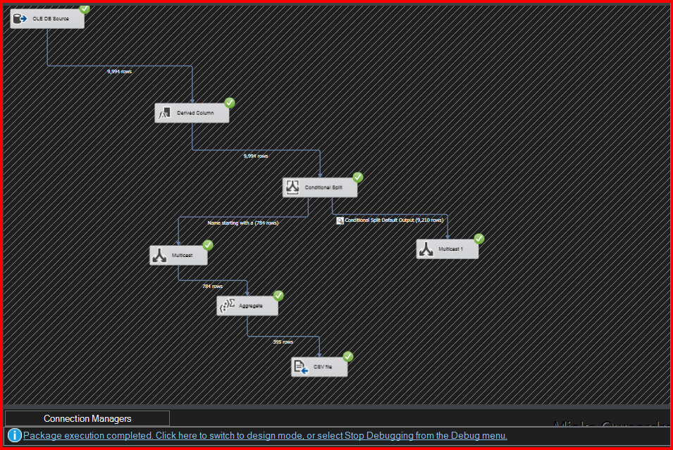

Output:

